Countdown to  
**Community Sidewalk Bible School**

**Countdown Counter here example: 106***Days***8***Hours***54***Minutes***58***Seconds*

**JUNE 2-6, 2025**

[Sign Up Here!](https://docs.google.com/forms/u/0/d/e/1FAIpQLSdovp-RW9iCuFiGRWTH-LOlPQoUItIFThmrIpysLiD9MRgefw/formResponse)

[Volunteer Here!](mailto:ArmstrongArtisanFarm@Outlook.com)

[Need A Ride? Let Us Know Here!](mailto:ArmstrongArtisanFarm@Outlook.com)

[Questions? Call or Text Us Here!](tel:3364805288)

**Find Hidden Treasures in the Bible This Summer!**

Scroll down to see all the fun we’ll have!

**WORSHIP**

The Community Sidewalk Bible School (VBS) is meant to bring the Word of Jesus into the heart of town. We hope that you will bring your child to this great experience! We have a van that will gladly pick your child up each night if they need a ride. Please call or text (336)480-5288. Your kids will get to hear about Missionaries who’ve given their life to the Lord, great songs that have been sung through many generations, games, skits, food, prices and most importantly preaching and teaching from God’s WORD. This is a special time for your kids to grow spiritually. HAVE A YOUNGER CHILD LESS THAN 7 THAT WANTS TO COME? WE INVITE YOU TO STAY WITH YOUR CHILD AND JOIN US EACH NIGHT!

**Powerful Teaching & Preaching**

This is a burden that the Sidewalk Bible School team shares! It is about the community, God and God’s Word. We will have a great time all week long, but there will be an emphasis on God’s word and the teaching and preaching will be in a way for your child to relate and understand. We pray that God will save souls and instill a greater desire for the children to know and serve God. Envision a fun-filled week for kids to grow in Christ and have fun with crafts, Bible stories, signing, games and food! Pre-register with the link at the top of the page today!

**CRAFTS & GAMES!!**

This event will be similar to church camp all condensed into one afternoon! We hope your child can walk to the Community Sidewalk Bible School via the sidewalk, your designated ride or give us a call and we will pick you up. This will be a friendly, loving and safe environment for the kids.

**FOOD PROVIDED NIGHTLY!!**

Hungry? We will provide food after the service NIGHTLY for the kids. FRIDAY NIGHT WILL BE FAMILY NIGHT! We have an exciting lineup of speakers, singing and many activities that your children are going to love. These will be unforgettable memories that will impact your children and family. Don’t miss this event! We look forward to you being there! Don’t hesitate to reach out if you have questions to (336)480-5288.

**Free Bibles will be given by the church to any child or guest who needs one.**

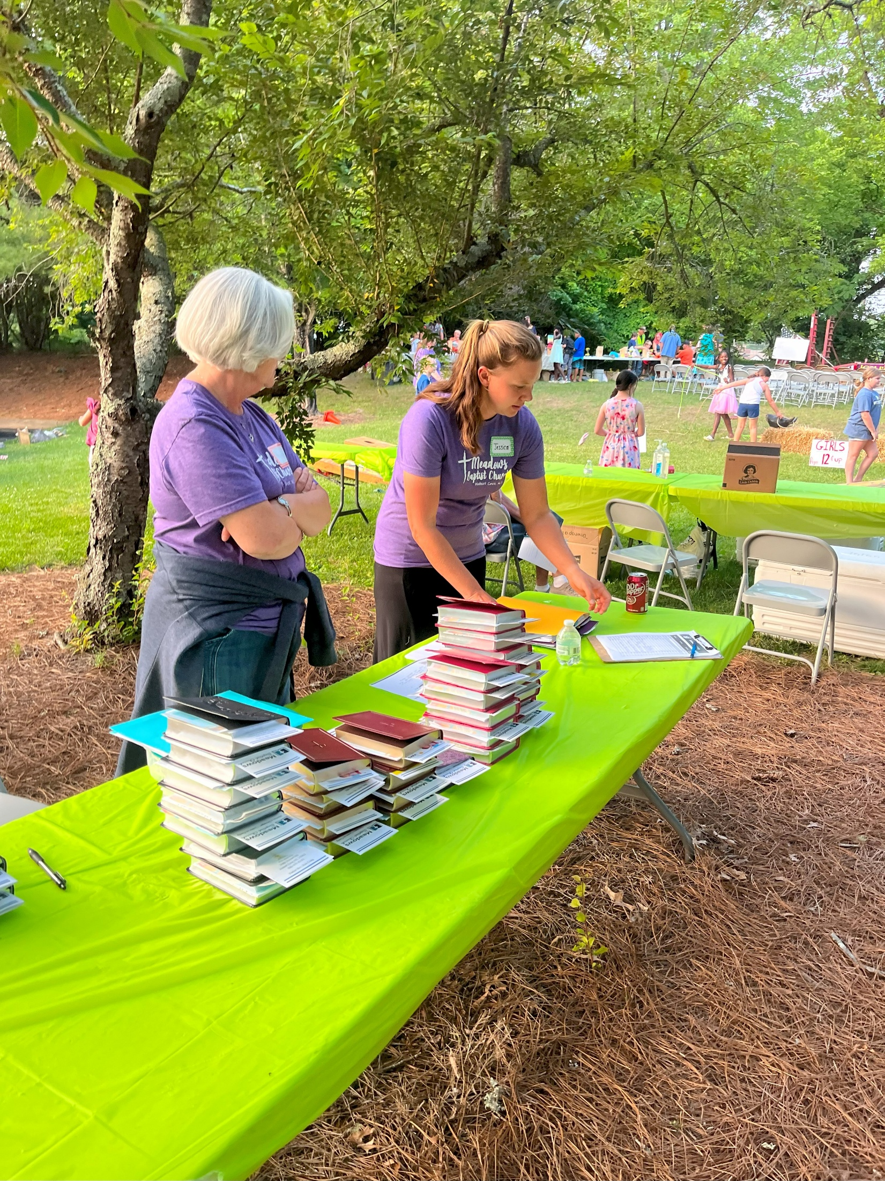

Our kids need to learn value of God’s Word – The Bible! Don’t have a Bible? You will get to choose from Purple, Pink, Red, Brown, Green, Black or Blue! We can’t wait to see you at the Community Sidewalk Bible School!

**When: June 2-6, 2025**

**6pm-8:30pm**

**CALENDER .ICS LINK FOR PEOPLE TO SAVE FILES**